Lab Report
Use this template to document your work as you complete your assignment.

Your Information
Your Name: Jacoreua Graham
Assignment Title: 5.5 Performance Assessment Scenario Analysis

Screenshots
As you complete the procedure, add the screenshots for the required step(s) below. Be sure to include your computer system date and time.

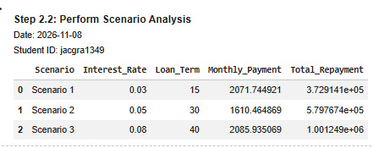
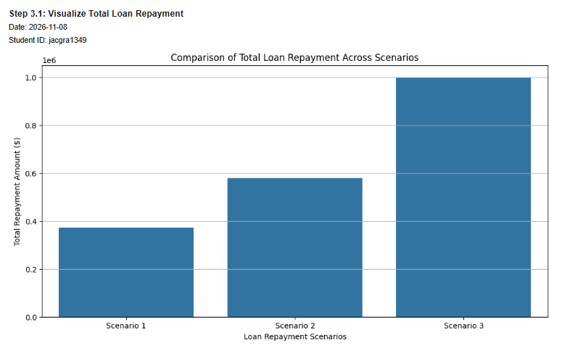
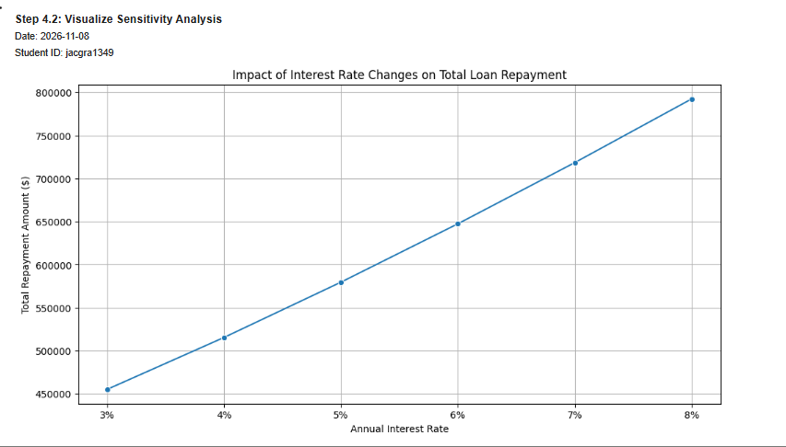

Questions
Answer the required questions in the space below.
- What differences were observed between the scenarios?
The three scenarios differed based on interest rates and repayment periods. The scenario with a 3% interest rate and a 15-year repayment period had the lowest repayment amount of $372 914.09. Scenario 2 with a 5% interest rate and a 30-year repayment period had $579,767.35, and lastly, scenario 3 with an 8% interest rate and a 40-year repayment period had $ 1,001,248.83. This shows that higher interest rates and longer repayment periods lead to a higher total repayment amount.
- How did changes in key variables affect the outcomes in the sensitivity analysis?

When the annual interest rate was increased, monthly payments and total loan repayment increased. The interest rate was varied from 3% to 8%, while the principal amount remained at $ 300,000 and the repayment period was 30 years. At a 3% interest rate, the total loan repayment was about $455332.36. At 8%, however, the total repayment increased to $792,465.74; monthly payments also increased from $ 1,264.81 to $ 2,201.29. Thus, increasing interest rates lead to higher borrowing costs.

